1-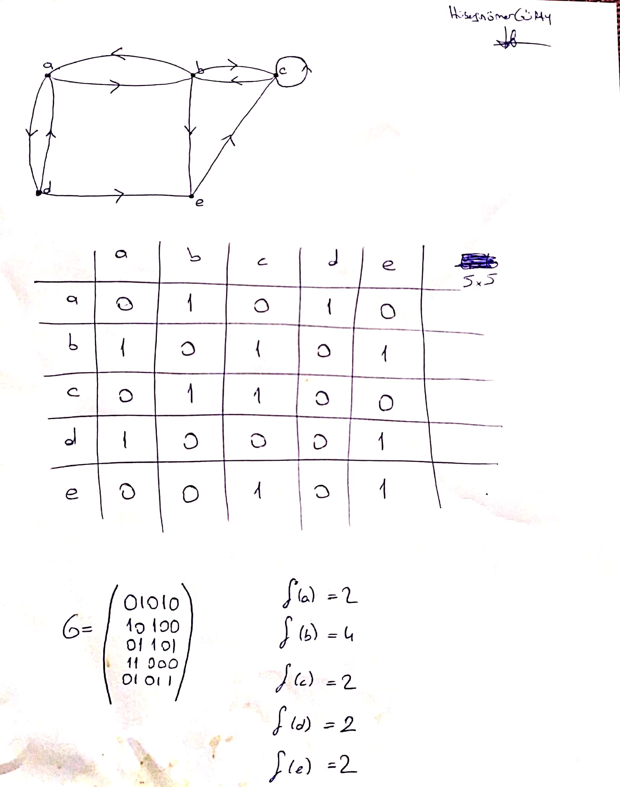5 Letter exist so 5 column and 5 row will be exist.

If there is a connection between column and row , we put 1 else zero.

2-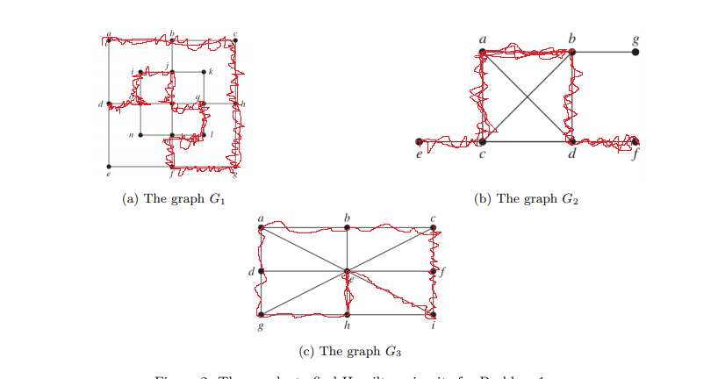

1. There is no Hamilton circuit , Because we cant go over all vertex without repeats from starting vertex
2. There is no Hamilton circuit , Because we cant go over all vertex without repeats from starting vertex
3. Lots of Hamilton circuits exist in this case I will write some of these
4. e,a,b,c,f,i,h,g,d,e
5. e,a,d,g,h,I,f,c,b,e
6. e,d,g,h,i,f,c,b,a,e
7. e,d,a,b,c,f,I,h,g,e
8. e,g,h,i,f,c,b,a,d,e

and more…

3-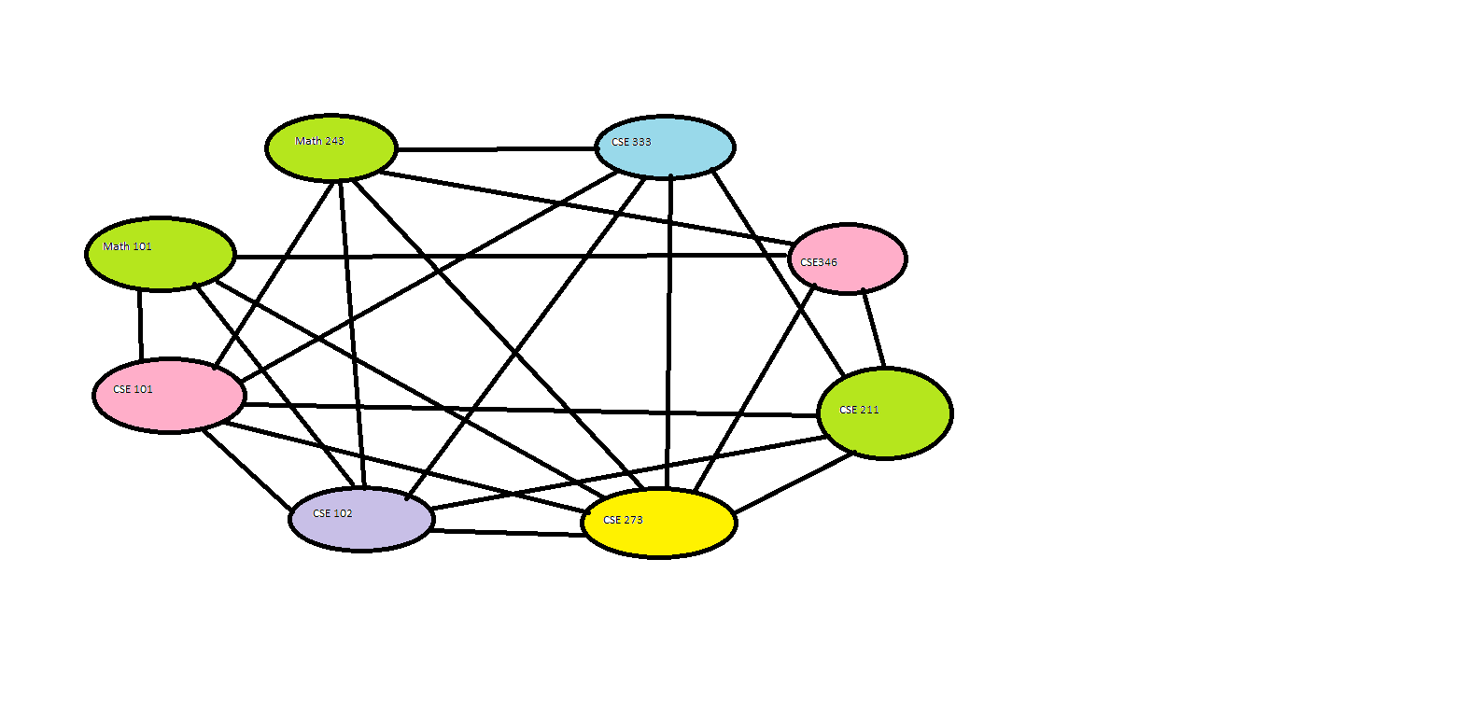

Math 101 , Math 243 and CSE 211 are independent each other so one color for them

CSE101 depends on all lessons except CSE 346 so these two have a one color.

Also CSE 102 depends on all lessons except CSE 346 so CSE 102 have special color.

CSE273 depends on all lessons so it has special color and finally CSE 333 depends on all colors so it has to be different color.